Disability Policy Insights: Official Development Assistance

Official Development Assistance belongs on the disability rights agenda
Official Development Assistance (ODA) is a resource mandated to “promote…the economic development and welfare” of Global South countries (OECD, n.d. c). Budgeting to uphold the rights of persons with disabilities is primarily the responsibility of individual states. (Article 3, UN Declaration on the Right to Development; UN SRD, 2020; Balasubramanian, 2025). However, ODA can and should be used to complement these efforts. Accordingly, putting the rights of persons with disabilities at the heart of ODA policy and programming is vital for several reasons:

Persons with disabilities in the Global South face widespread social and economic inequalities
It is estimated that persons with disabilities make up 12.8% of the population in Low-Income Countries, rising to 14.8% in Lower Middle-Income Countries and 16.2% in Upper Middle-Income Countries (WHO, 2022). Yet, due to discriminatory barriers, persons with disabilities and their households fare substantially worse across a wide range of social and economic indicators, from health to multidimensional poverty to employment (UN DESA, 2024). Redressing the inequalities that persons with disabilities face requires public resources, and ODA can play an important role as a complement to government budget allocations.

2. Countries have made international commitments to ensuring international cooperation is inclusive and accessible
CRPD Article 32 requires governments to ensure that “international cooperation, including international development programmes, is inclusive of and accessible to persons with disabilities” (Article 32, CRPD). All Global North governments with ODA budgets have ratified or acceded to the CRPD, except the USA (UN OHCHR, n.d.). The European Union, which is an important multilateral administrator of ODA, has also ratified the CRPD (UN OHCHR, n.d.).

On the other hand, all Global North governments with ODA budgets, except the USA, have committed to the 2030 Agenda for Sustainable Development, which incorporates the Sustainable Development Goals (SDGs). The 2030 Agenda contains 11 explicit references to persons with disabilities. It also implicitly includes persons with disabilities through language that encompasses all people. Further, the Agenda’s overarching pledge to “leave no one behind” means the Goals cannot be met unless persons with disabilities are included. (Lockwood, n.d.; UN, 2015).
Furthermore, many countries receiving ODA have also ratified the CRPD and have local legislation focused on disability inclusion. Governments with ODA budgets must use ODA in ways that support and complement national efforts to promote the rights of persons with disabilities, in close consultation with local representative organisations of persons with disabilities.

3. Significant resources are at stake
Between 2016 and 2024, total ODA levels ranged from around USD 160 billion to around USD 240 billion. These significant resources represent a risk, as well as an opportunity. It can be particularly problematic if ODA resources are not used in CRPD-compliant ways, and even worse if they create new barriers, like funding new construction that is inaccessible and expensive to retrofit. Thus, if ODA programmes are not inclusive of persons with disabilities, it can be expected that they will exacerbate inequalities between persons with disabilities and the rest of the population (Groce and Kett, 2013). In other words, persons with disabilities will be worse off, in relative terms, than before the ODA programme was funded (Groce and Kett, 2013). Recent research gives some support to this expectation: data from 40 Global South countries suggest that “disability inequalities related to education, employment, and multidimensional poverty are found to be significantly larger in countries at higher levels of development” (Lewis et al, 2022). Of course this does not mean that ODA programmes should cease. Rather, it is essential to take into account the severe unintended consequences that can occur, unless deliberate steps are taken to uphold the rights of persons with disabilities.
---
The reality is that in some countries, ODA accounts for a substantial share of total disability-specific resources. For example, recent analysis on domestic budgets and ODA grants in four countries found that in some of these countries, “the value of ODA principally targeting disability inclusion is found to be comparable to disability-focused public domestic expenditures”, while in other countries domestic expenditures were much greater than disability-specific ODA (Knox-Vydmanov and Côte, 2025, p.40; Figure 1 below). So while it is paramount for organisations of persons with disabilities to do budget analysis and engage in domestic budget accountability mechanisms (Balasubramanian, 2025), ODA can be a worthwhile focus for analysis and advocacy as well.
Figure 1: Comparison of disability-specific government expenditure with disability-specific ODA grant disbursements (score 2) (% of Gross Domestic Product, 2023)
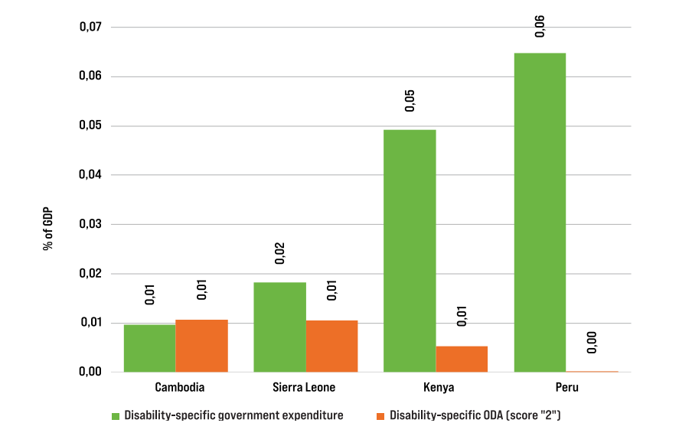
Source: Charles Knox-Vydmanov and Alexandre Côte, 2025, “Financing acceleration of disability inclusion in low- and middle-income countries”, p.40. The ODA analysis uses data on allocable ODA (For more details on allocable ODA, see OECD-DAC Working Party on Statistics, 2020, p.19.)
Now is a critical time for scrutinising ODA, as ODA budgets are falling sharply. At the time of writing, the Organisation for Economic Cooperation and Development (OECD) predicted that, “ODA from DAC [Development Assistance Committee] countries is projected to decline by 9 to 18% from 2024 to 2025. The outlook beyond 2025 is highly uncertain” (OECD, n.d. c). As organisations across civil society call for the cuts to be reversed, it will be important for disability advocates to contribute evidence of how the cuts are having discriminatory effects for persons with disabilities. For example, if governments cut ODA activities that mainstream disability inclusion, but keep ODA activities that do not include persons with disabilities, this would be discrimination.

The current situation
Although there has been progress since the CRPD was adopted (UN SRD, 2020), research has persistently highlighted gaps in how organisations approach disability inclusion in ODA. For example, a report by the UN Special Rapporteur on the rights of persons with disabilities in 2020 found that a substantial number of organisations paid insufficient attention to disability in their policies; that some organisations lacked confidence in their capacity for CRPD-compliant programming; and that there were gaps in disability-inclusive monitoring and evaluation (UN SRD, 2020).
To form a complete and up-to-date judgment on how far ODA is inclusive of, and accessible to, persons with disabilities, a wide range of quantitative and qualitative evidence is needed, from disability-disaggregated data on ODA activities’ results, to feedback from diverse persons with disabilities in the localities where ODA-funded activities take place. But even a more narrowly focused analysis can give some important clues. A major focus for CIP’s work on ODA (e.g. CIP, 2026) has been the data in the OECD-DAC’s database, in particular the disability marker (Box 1). Provided its limitations are understood, the disability marker can offer some important insights into disability-related ODA spending.
Box 1: the OECD-DAC disability marker
The OECD-DAC disability marker is a tool to track how far ODA activities aim to promote the inclusion and empowerment of persons with disabilities. The marker, introduced in 2018, uses a three-point scoring system:
- Score 2 means that inclusion and empowerment of persons with disabilities is the principal objective of the activity.
- Score 1 means that inclusion and empowerment of persons with disabilities is a significant objective of the activity (but not the main reason why the activity was undertaken).
- Score 0 means that the activity either only aims for disability inclusion and empowerment in a marginal way or does not consider them at all.
As well as these three scoring options, organisations that report ODA data to the OECD-DAC also have the option to leave the marker blank.

Source: CBM Global Disability Inclusion (CBMG), 2025, “One in five is not enough: disability inclusion still missing in climate and gender aid”, p.10; OECD-DAC Working Party on Statistics (WP-Stat), 2020, “The OECD-DAC policy marker on the inclusion and empowerment of persons with disabilities: Handbook for data reporters and users”, pp.5, 10-11, 14.
For this brief, our analysis of the disability marker data examines three main measures (Figure 2):
- The total level of ODA marked using the disability marker (scores of 0, 1, or 2). This measure matters because, if the marker is not used, this is a serious barrier to transparency over ODA spending related to disability (see finding 1 below).
- The total level of disability-related ODA (scores of 1 or 2). This measure matters because if an ODA activity does not meet the threshold to be reported as disability-related, then it is very unlikely to be living up to the CRPD requirement that ODA should be “inclusive of and accessible to” to persons with disabilities (see finding 2).
- The total level of disability-specific ODA (score of 2). This measure matters because disability-specific activities can potentially play a crucial role in addressing disability-focused priorities. For example, depending on local policies and on the views of the local disability movement, there may be a role for ODA in resourcing organisations of persons with disabilities, supporting data collection, or facilitating access to assistive technology. (See also EDF, 2024). (See finding 3).
Figure 2: measures used in our analysis
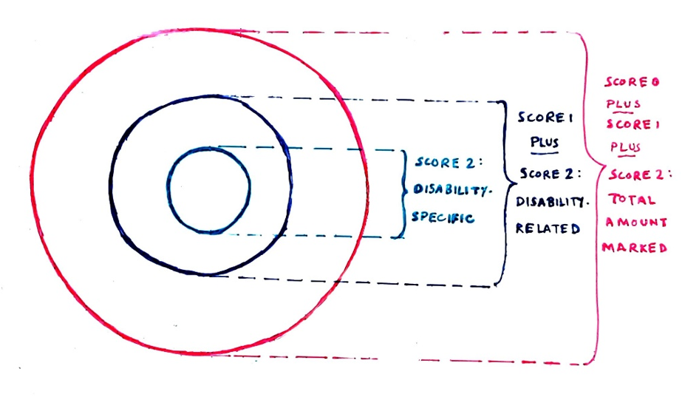
Source: author’s elaboration built on CBMG, 2025. Circle sizes have been chosen for ease of reading and do not represent the actual scale of ODA that was given the different respective scores.
We found that:
- Low uptake prevents the disability marker from reaching its full potential as a tool for accountability and learning.
In 2024, 61.8% of ODA spending had the disability marker left blank. To give a sense of scale, the value of ODA that was not marked was more than twice the total value of ODA to all countries in Asia.
Uptake of the disability policy marker is particularly low among governments that are not members of the OECD-DAC, and among multilateral organisations (although, encouragingly, the Asian Development Bank applied the marker to the majority of its ODA for the first time in 2024). Yet even looking at just members of the OECD-DAC, almost half (46.4%) of ODA spending had the disability marker left blank. Some OECD-DAC members responsible for very large values of ODA (e.g., France) leave the majority of their ODA spending unmarked.
- Reported levels of disability-related ODA (scores 1 or 2) are low
Even if we exclude governments and organisations that do not use the disability marker at all from our analysis, we still find that, in 2024, only around one out of every five dollars (21.1%) of ODA was reported to be disability-related (see a full breakdown of reported marker scores in Figure 3). Yet as mentioned above, under CRPD Article 32, disability-related ODA should be the norm, not the exception. In 2024, over 58 billion USD was given a disability marker score of 0. In other words, over 58 billion USD did not target disability inclusion and empowerment in any significant way. As argued previously, some of these ODA activities may even have risked exacerbating inequalities between persons with and without disabilities. To put this in context, 58 billion USD was considerably more than the total value of ODA to Latin America and the Caribbean, Europe, and Oceania combined.

Figure 3: Reported disability marker scores in 2024
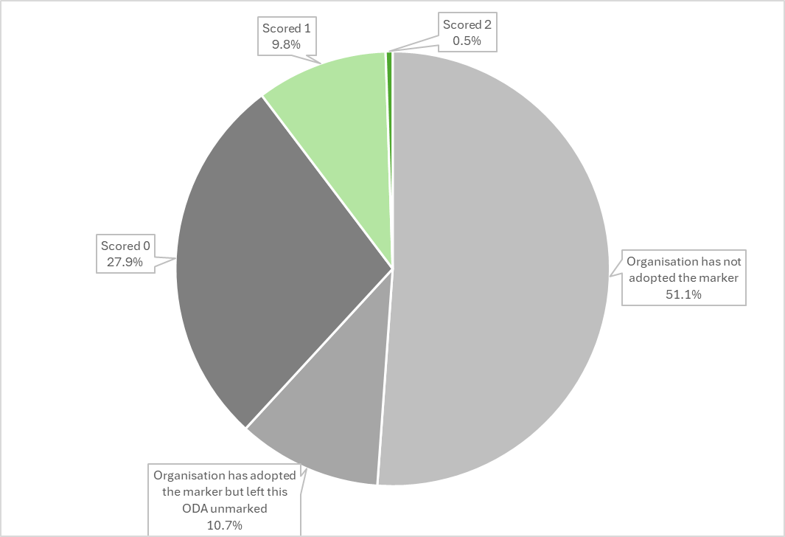
Source: author’s analysis of the OECD’s Creditor Reporting System (flows) dataset (OECD, n.d. b). The design of the chart takes inspiration from Charles Knox-Vydmanov and Alexandre Côte, 2025, “Financing acceleration of disability inclusion in low- and middle-income countries”, p.35.
Moreover, the true level of CRPD-compliant ODA may be less than the results in Figure 3 suggest. This is due to limitations in the design and implementation of the disability marker (Box 2). In particular, marker data are self-reported, and there is a risk that reporters may misinterpret the scoring criteria in ways that lead to over-reporting ODA as disability-related (see e.g. EDF, 2024). Testing this risk fully requires detailed research, but one warning sign of potential over-reporting is when large ODA activities do not mention disability in their project descriptions on the OECD-DAC database, contrary to the OECD-DAC’s guidance (OECD-DAC WP-Stat, 2020, p.15). In 2024, 10 large ODA activities accounted for 25% of the total value of ODA that was given a score of 1, yet not one of these 10 activities referred to disability in their database entries.
Box 2: Limitations of the OECD-DAC disability marker
Although the OECD-DAC disability marker is the, “best available way to analyse patterns across large numbers of ODA activities” (CBMG, 2025, p.12), it has some substantial limitations. Recognising these limitations is important, or else marker data may inspire misleading conclusions. For example, it may seem that levels of CRPD-compliant ODA are higher than is really the case. Some of the main limitations include:
- Uptake of the marker is low, particularly among multilateral organisations (see above).
- Data are self-reported, so there is a risk of misreporting, in particular over-reporting (see above). Even more serious, there is a risk that activities affecting persons with disabilities in harmful ways (for example, support for segregated institutions) could mistakenly be reported as “disability-related”/”disability-specific” (see below).
- At the time of writing, the marker eligibility criteria do not fully reflect the expected characteristics of a fully CRPD-compliant ODA activity (EDF, 2024). For example, activities can be reported as “disability-related” even if they do not actively involve representative organisations of persons with disabilities. The OECD is currently reviewing the marker minimum criteria.
- The OECD-DAC’s marker system does not allow analysis on different overlapping forms of inequality, apart from gender. This is because most forms of inequality do not have dedicated markers (see e.g. HelpAge International, 2024).
- The marker is applied at the start of activities, so it informs us about the activities’ intentions, but does not record results (Atlas Alliance, 2023).
- The marker is applied to whole activities, not disability components or budget lines. In the case of score 1 activities, where disability is not the driving reason for the activity, the marker tells us about the activity’s overall approach to disability, but it does not tell us about the amount of funds devoted directly to disability-related actions within the activity (OECD-DAC WP-Stat, 2020). Nor does it mean that all sub-components of the activity are necessarily disability-inclusive (EDF, 2024).
- Finally, the OECD-DAC’s Creditor Reporting System database, where detailed data on the disability marker is stored, is not fully accessible to screen-reader users. This seriously restricts opportunities for some persons with disabilities to ask their own questions of the data and conduct their own analysis. (Personal correspondence with Tod Emko and Dr Elizabeth Lockwood, 2025; see also CBMG, 2024).

- Reported levels of disability-specific ODA (score 2) have increased, but remain very low
In 2024, if we exclude from our analysis those governments and organisations that do not use the disability marker, we find that 1.1% of ODA spending was reported to be disability-specific . This is an increase from 0.3% in 2023. However, it is very doubtful that 1.1% represents a sufficient commitment to supporting disability-specific activities, considering the vital role that these can potentially play in addressing disability-focused priorities (as discussed above).
As mentioned in Box 2, there is some risk that activities which harm persons with disabilities may mistakenly be reported as disability-related or disability-specific. Alarmingly, based on the available project descriptions in the OECD-DAC’s database, it does appear that some activities reported as “disability-specific” in 2024 actually involved support for segregated residential institutions, in violation of the CRPD. Examples of such projects are given in Box 3. Please note that more inquiries would be needed to confirm for certain that these are harmful projects and that the database text was not misleading, but on the surface, the evidence suggests a very high risk. Moreover, these findings may be the tip of the iceberg: for many other activities in the database, there was insufficient information to judge whether the activity may actually be harmful.
Box 3: Examples of reported “disability-specific” activities that appear to involve supporting harmful institutions
- “Supporting a local shelter housing children and adults with disabilities” in South Africa.
- “Improvement of the hygienic conditions at a facility for the mentally-challenged”, in Serbia.
- Purchasing furniture for bedrooms at an “orphanage for mentally disabled children” in Belarus.
Source: author’s analysis of the OECD’s Creditor Reporting System (flows) dataset (OECD, n.d. b)
- Combining disability marker data with other sources can offer rich insights
As the findings show, disability marker data can give some important insights, despite its limitations. But, if researchers are seeking a more in-depth understanding of a particular government or theme, then comparing marker data with other sources can give a more three-dimensional view.
In particular, comparing with other sources can help researchers learn more about the reliability of reported marker data. For example, the European Disability Forum (a regional organisation of persons with disabilities) took a sample of activities that the European Commission had reported as disability-related in 2022, and compared the reported disability marker scores against activity documentation. It found that seven of the 15 sampled activities appeared to have been scored too highly, suggesting that true levels of disability-related European Commission ODA may be lower than the marker data suggest (EDF, 2024). Similarly, researchers have used qualitative data sources (e.g. activity documents, email inquiries and interviews) to assess the reliability of Norwegian and Danish disability marker data. They found that, within each of these countries’ ODA, interpretation of the criteria for a marker score of 1 was not always consistent, reducing the reliability of the marker results (Larsen and Nilsson, 2021; Nilsson, 2024).
Further examples of different ways in which organisations of persons with disabilities, civil society organisations and others have worked with the marker data are given in the reference list, to illustrate the wide range of inquiries that are possible. The reference list also includes links to data sources and tools for disability advocates who are interested in conducting their own bespoke analysis on the data.

The way forward: 6 key recommendations
The following recommendations are critical to move towards more inclusive, equitable, ODA, in line with the CRPD:
      - Make ODA inclusive of, and accessible to, persons with disabilities. In general, ODA should at least meet the criteria for a score of 1 on the OECD-DAC disability marker: if an ODA activity does not meet the threshold to be reported as disability-related, then it is very unlikely to be living up to the CRPD requirement that ODA should be “inclusive of and accessible to” to persons with disabilities. While meeting the criteria for a score of 1 on the disability marker is generally necessary, it may not be sufficient: for ODA to be truly disability-inclusive and equitable, the real acid test is that it must comply fully with the CRPD.
      - Explore opportunities to increase ODA for disability-specific activities. Reported levels of disability-specific ODA are currently very low; most governments or multilateral organisations that administer ODA should have a strong presumption that these levels need to increase. The best approach depends on the context. Governments with ODA budgets need to assess what disability-specific, CRPD-compliant activities the governments of the targeted Global South countries plan to undertake. This assessment should include a disability-inclusive budget analysis to identify how far planned activities are funded. They can then decide, in close consultation with representative organisations of persons with disabilities, how ODA can best support or complement these government activities.
      - Avoid using ODA in ways that do harm. ODA should not be used to fund initiatives that directly violate the rights of persons with disabilities per the CRPD. For example, ODA should not be used to fund institutionalised care for persons with disabilities, but should instead fund community-based support. Similarly, ODA should not be used to fund the construction of inaccessible public buildings or services, such as public transportation.
      - Take a holistic approach to promoting inclusion, equality and non-discrimination. Efforts to make ODA disability-inclusive should be part of a wider commitment to promote and fund inclusion, equality and non-discrimination of diverse population groups (for example, older people, racialised people, LGBTQI people, among others). Since different characteristics often overlap and intersect, ODA should target multiple groups simultaneously whenever appropriate, and should pay particular attention to people experiencing intersecting inequalities. ODA must also pay attention to underrepresented types of disabilities.
      - Enhance data quality, transparency and accessibility.
Key priorities include:
- Increasing use of the OECD-DAC disability marker. Governments should apply the marker to all relevant ODA spending. They should also advocate for their multilateral partners to adopt the marker.
- Improving the quality of disability marker reporting through training and quality assurance checks. In particular, governments should review whether their “disability-related” activities may mistakenly include any activities that actually risk doing harm. They should consult with experts, including organisations of persons with disabilities, if they are in any doubt.
- Ensuring that the OECD-DAC’s ongoing review of the disability marker eligibility criteria results in stronger criteria that align with the CRPD (see, e.g., EDF 2024), and that these new criteria are followed robustly.
- Supporting the OECD-DAC to make its Creditor Reporting System database accessible. While the database remains inaccessible, some disability advocates may incur extra costs (e.g., personal assistance) in trying to access the data; governments should budget to support disability advocates with these costs (see CBMG 2024).
      - Promote meaningful participation of persons with disabilities and their representative organisations in all stages of ODA design, implementation and monitoring. Governments with ODA budgets should recognise the expertise that persons with disabilities bring to their ODA policy and programming. They should ensure that processes for engaging persons with disabilities are fully accessible, and should provide resources and necessary accommodations to ensure persons with disabilities can participate meaningfully. They should make particular efforts to guarantee the involvement of underrepresented persons with disabilities.

References and additional resources

Data sources and guidance
Center for Inclusive Policy (CIP). 2026. “Working with the Organisation for Economic Cooperation and Development’s disability marker for Official Development Assistance: guide for screen reader users”.
Organisation for Economic Cooperation and Development (OECD). N.d. a. “OECD Data Explorer”. DAC 1: Flows by provider (ODA + OOF + Private). Data downloaded 13 February 2026. https://data-explorer.oecd.org/vis?lc=en&fs[0]=Topic%2C1%7CDevelopment%23DEV%23%7COfficial%20Development%20Assistance%20%28ODA%29%23DEV_ODA%23&pg=0&fc=Topic&bp=true&snb=20&df[ds]=dsDisseminateFinalDMZ&df[id]=DSD_DAC1%40DF_DAC1&df[ag]=OECD.DCD.FSD&df[vs]=1.7&dq=DAC._Z...1160..V%2BQ&lom=LASTNPERIODS&lo=10&to[TIME_PERIOD]=false
OECD. N.d. b. “OECD Data Explorer”. Creditor Reporting System (flows). Data for the years 2024 and 2023 downloaded on 6 March and 14 February 2026 respectively. https://data-explorer.oecd.org/vis?lc=en&fs[0]=Topic%2C1%7CDevelopment%23DEV%23%7COfficial%20Development%20Assistance%20%28ODA%29%23DEV_ODA%23&pg=0&fc=Topic&bp=true&snb=20&df[ds]=dsDisseminateFinalDMZ&df[id]=DSD_CRS%40DF_CRS&df[ag]=OECD.DCD.FSD&df[vs]=1.6&dq=DAC..1000.100._T._T.D.Q._T..&lom=LASTNPERIODS&lo=5&to[TIME_PERIOD]=false
OECD Development Assistance Committee Working Party on Statistics (OECD-DAC WP-Stat). 2020. “The OECD-DAC policy marker on the inclusion and empowerment of persons with disabilities: Handbook for data reporters and users”. https://one.oecd.org/document/DCD/DAC/STAT(2020)48/en/pdf
OECD-DAC Working Party on Statistics. Forthcoming. New edition of the disability marker handbook.

Analysis on disability inclusion, equality and rights in ODA
CBM Global Disability Inclusion (CBMG). 2024. “Tracking aid for persons with disabilities: Why the OECD-DAC Disability marker can be a powerful advocacy tool for organisations of persons with disabilities – and recommendations on how to make it even more effective.” https://cbm-global.org/wp-content/uploads/2024/06/DAC-Marker-publication-June-2024.pdf
CBMG. 2025. “One in five is not enough: disability inclusion still missing in climate and gender aid”. https://cbm-global.org/wp-content/uploads/2025/12/CBM-Global-One-in-five-is-not-enough-Dec1.pdf
European Disability Forum (EDF). 2024. “Steady progress, serious shortfalls: disability inclusion in EC ODA projects”. https://www.edf-feph.org/publications/steady-progress-serious-shortfalls-disability-inclusion-in-ec-oda-projects/
EDF. 2025. “No time to lose: assessing EU ODA for disability inclusion, 2018-2023”. https://www.edf-feph.org/content/uploads/2025/12/Final-DAC-marker-report-2025.docx
Inclusion International. 2020. “Excluded from the excluded: people with intellectual disabilities in (and out of) Official Development Assistance.” https://s38312.pcdn.co/wp-content/uploads/Excluded-from-the-Excluded_new.pdf
Knox-Vydmanov, Charles and Alexandre Côte. 2025. “Financing acceleration of disability inclusion in low- and middle-income countries: a background paper for the Global Disability Inclusion Report”. UNICEF, pp.35-40. https://www.globaldisabilitysummit.org/wp-content/uploads/2025/03/GIP03351-UNICEF-GDS-Financial-Background-Paper-v3.pdf
Loryman, Hannah and Nick Thorne. 2024. “OECD DAC disability and gender markers: data analysis 2018 – 2022”. Sightsavers. https://www.sightsavers.org/wp-content/uploads/2024/04/Sightsavers-OECD-DAC-data-analysis.pdf
Meeks, Polly. 2023. “Tracking disability inclusive development: Making the most of the OECD-DAC disability inclusion policy marker to promote equality and inclusion in international development and humanitarian assistance.” Atlas Alliance. https://www.atlas-alliansen.no/en/reports
Sightsavers. N.d. “OECD DAC dashboard”. Accessed 16 February 2026. https://app.powerbi.com/view?r=eyJrIjoiZGFlMGE0YzMtOGJjMC%0A00YjQ2LWJlNzctYzk1OTczOGJkNjQxIiwidCI6IjA1Y2UxY2JkLT%0AFkOWQtNDRiYS04YzFkLTJmZjk3ZWU0YjZmZiIsImMiOjh9

Other references
Balasubramanian, Meenakshi. 2025. “Disability policy insights: budget analysis”. Center for Inclusive Policy, Policy Brief no.3. https://inclusive-policy.org/wp-content/uploads/2025/09/Disability-Policy-Insights-3-2.pdf
Banks, Lena Morgon, Hannah Kuper and Sarah Polack. 2017. “Poverty and disability in low- and middle-income countries: A systematic review”. PLOS ONE 12(12): e0189996. https://doi.org/10.1371/journal.pone.0189996
Benn, Julia and Friederike Rühmann. 2020. “Peer reviews on development finance statistics – lessons learnt from seven pilots”. OECD Development Co-operation Working Papers. No. 85, p.22, bullet no.4. https://www.oecd.org/content/dam/oecd/en/publications/reports/2020/10/peer-reviews-on-development-finance-statistics_9136e3de/9f6598d0-en.pdf
Groce, Nora and Maria Kett. 2013. “The disability and development gap”. Leonard Cheshire Disability and Inclusive Development Centre, Working Paper Series: no.21. https://dx.doi.org/10.2139/ssrn.3385372
HelpAge International. 2024. “Investing in equality: assessing the funding gap for older women”. https://www.helpage.org/wp-content/uploads/2024/09/Investing-in-Equality.pdf
Larsen and Nilsson. 2021. “Mapping of Norwegian efforts to include persons with disabilities in development assistance, 2010-2019”, p.12 and section 2.4.2 on pp.13-14. https://www.norad.no/contentassets/13766aa6da5a495590fbae46383761f5/1.21_mapping-of-norwegian-effort-to-include-persons-with-disabilities-in-development-assistance-2010-2019
Lewis, Emily, Sophie Mitra and Jaclyn Yap. 2022. “Do Disability Inequalities Grow with Development? Evidence from 40 Countries”. Sustainability 2022, 14(9), 5110. https://doi.org/10.3390/su14095110
Lockwood, Elizabeth. N.d. “’Nothing about us without us’: Disability, the SDGs and the UNCRPD”. Part of the London School of Hygiene and Tropical Medicine’s course on Global Health and Disability, on the FutureLearn website. Accessed 9 February 2026. https://www.futurelearn.com/info/courses/global-disability/0/steps/37575
Nilsson. 2024. “Mapping of Danish efforts to include persons with disabilities in development cooperation and humanitarian action: final report.” NIDS Development Services, commissioned by Disabled People’s Organisations Denmark, pp.11-13. https://handicap.dk/files/media/document/Final%20Report%20Disability%20Inclusion%20in%20Danish%20Aid%202024-06-21.pdf
OECD. N.d. c. “Official development assistance (ODA)”. Accessed 15 February 2026. https://www.oecd.org/en/topics/policy-issues/official-development-assistance-oda.html. The projected cuts to ODA were last updated in November 2025.
United Nations (UN). 1986. Declaration on the Right to Development. https://www.ohchr.org/en/instruments-mechanisms/instruments/declaration-right-development
UN. 2007. Convention on the Rights of Persons with Disabilities. https://www.un.org/disabilities/documents/convention/convoptprot-e.pdf
UN. 2015. “Resolution adopted by the General Assembly on 25 September 2015. Transforming our world: the 2030 Agenda for Sustainable Development”. https://docs.un.org/en/A/RES/70/1
United Nations Committee on the Rights of Persons with Disabilities. 2018. “General comment No.7 on Article 4.3 and 33.3 - the participation of persons with disabilities in the implementation and monitoring of the Convention”. CRPD/C/GC/7. https://www.ohchr.org/en/documents/general-comments-and-recommendations/general-comment-no7-article-43-and-333-participation
United Nations Department of Economic and Social Affairs (UN DESA). 2024. “Disability and development report 2024: Accelerating the realisation of the Sustainable Development Goals by, for and with persons with disabilities”, chapters on Goal 1, Goal 3 and Goal 8. https://social.desa.un.org/publications/un-flagship-report-on-disability-and-development-2024
United Nations Office of the High Commissioner for Human Rights (UN OHCHR). N.d. “View the ratification status by country or treaty”. Ratification status for CRPD – Convention on the Rights of Persons with Disabilities. Accessed 9 February 2026. https://tbinternet.ohchr.org/_layouts/15/TreatyBodyExternal/Treaty.aspx?Treaty=CRPD
United Nations Special Rapporteur on the rights of persons with disabilities (UN SRD). 2020. “Disability-inclusive international cooperation”. A/75/186. https://www.ohchr.org/en/documents/thematic-reports/a75186-report-disability-inclusive-international-cooperation
United States (US) Mission to the UN. 4 March 2025. “Remarks at the UN meeting entitled 58th Plenary Meeting of the General Assembly”. https://usun.usmission.gov/remarks-at-the-un-meeting-entitled-58th-plenary-meeting-of-the-general-assembly/
World Health Organization (WHO). 2022. “Global report on health equity for persons with disabilities”, p.24. https://www.who.int/teams/noncommunicable-diseases/sensory-functions-disability-and-rehabilitation/global-report-on-health-equity-for-persons-with-disabilities

The report suggests that part of the reason why the estimate is lower in Low-Income countries may be reduced access to diagnoses, and limited opportunities to report conditions that lead to disability.
The USA formally rejected the Sustainable Development Goals in 2025. (US Mission to the UN, 2025).
Source: author’s analysis of the Organisation for Economic Cooperation and Development’s (OECD’s) DAC 1 dataset (OECD, n.d. a). Values are in constant 2023 USD, on a grant equivalent basis. The total includes ODA from all countries, both those that are members of the OECD Development Assistance Committee, and those that are not.
There is some nuance to this finding. Some indicators on people’s standard of living (e.g., access to safely managed water, adequate housing) did not show an increasing disability gap in countries with higher levels of “development”. The study’s authors observe that these standard of living indicators are measured at household level, whereas the indicators that did show an increasing disability gap are measured at individual level.
As per the OECD-DAC’s criteria for the disability marker, ODA activities that do not meet the threshold to be reported as disability-related include either a “marginal component” on disability, or none at all (OECD-DAC Working Party on Statistics, 2020, p.14). A marginal disability component is very unlikely to be enough to achieve full inclusion and accessibility. See also CBMG, 2025.
Source: all analysis from this point onwards uses data from the OECD’s Creditor Reporting System (flows) dataset (OECD, n.d. b). Data was downloaded on a commitments basis, in constant 2023 USD. The data includes ODA from all countries (whether or not they are members of the OECD-DAC) and from multilateral organisations. Negative commitments were removed from the analysis. The analysis only includes allocable ODA, in line with the OECD’s preferred methodology. (For more details on allocable ODA, see OECD-DAC Working Party on Statistics, 2020, p.19.)
All references in the text to “total ODA” are referring to total allocable ODA.
I.e., this ODA was given a score of 1 or a score of 2 on the disability marker.
As noted above, ODA activities that do not meet the OECD’s threshold to be reported as disability-related are very unlikely to be doing enough to achieve full inclusion and accessibility, as required by the CRPD.
There may also be a risk of under-reporting. However, the risk of over-reporting is likely to be greater, due to the incentives involved. See CBM Global, 2025, and Benn and Rühmann, 2020, fourth bullet on p.22.
Independent accessibility expert
CBM Global Disability Inclusion
I.e. this ODA was given a score of 2 on the disability-marker.
Translated from original language, with support of DeepL online translation tool
This includes suggestions of alternative approaches for screen reader users, while the OECD-DAC database remains inaccessible.
Lesbian, gay, bisexual, transgender, queer and intersex people
For some examples of under-represented types of disabilities, see UN Committee on the Rights of Persons with Disabilities, 2018, paragraph 50. However, the definition of under-represented types of disabilities depends on context and the list is not exhaustive.
The marker cannot be applied to administrative costs or core contributions to multilateral organisations (OECD-DAC Working Party on Statistics, 2020), and it is debatable how meaningfully it can be applied to budget support or debt relief.

